Unit 8 - Hip, Thigh & Pelvis Injuries: Review Packet

Directions: On the diagram below label the skeletal structures identified by each arrow.

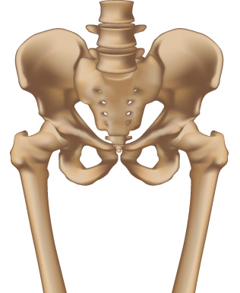

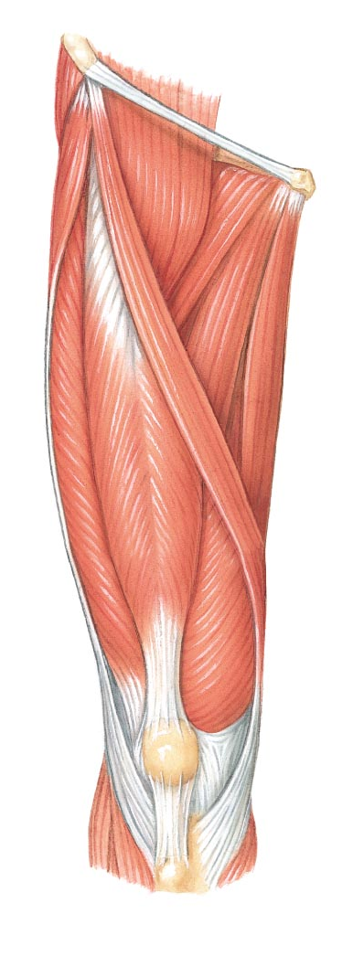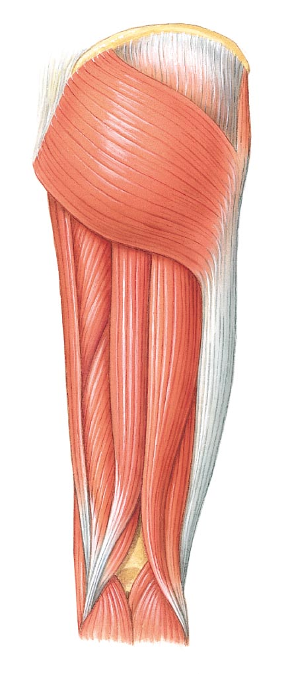
(below)

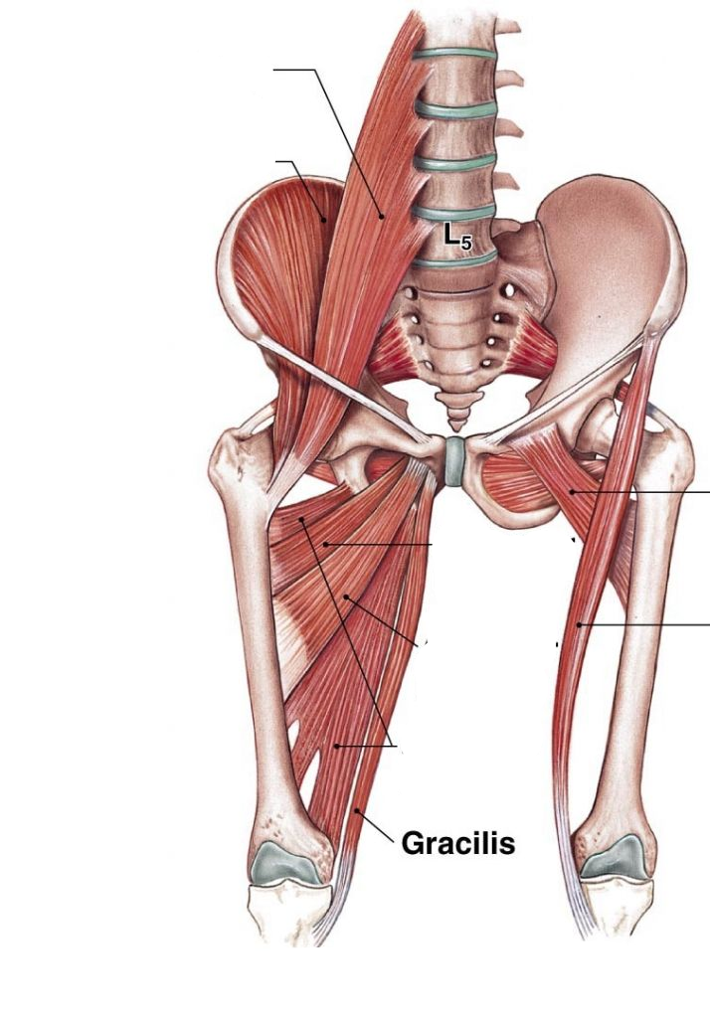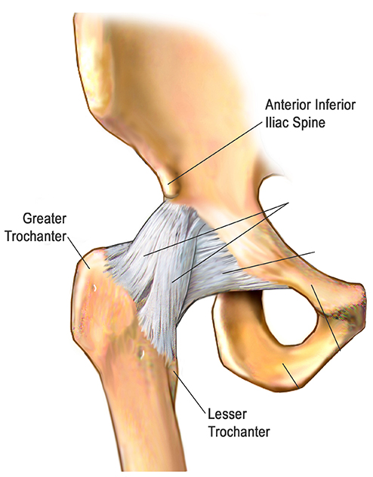
Fill-in-the-Blank

- A _____________ is a stretching or tearing of a muscle or tendon.
- A _____________ is a stretching or tearing of a joint capsule or ligament.
- A _____________ _________________ is an injury caused by an impact to the muscle which results in discoloration.
- A ___________ is an observable evidence of an injury.
- A _______________ is what the athlete tells you they feel.
- A ______________ is a description of how the injury occurred.

Matching

Injury Mechanisms
___ Quad Contusion A. Not warming up correctly
___ Iliac Crest Contusion B. Blow to quadriceps
___ Adductor Strain C. Blow to quadriceps causing blood vessels to burst
___ Hamstring Strain D. To much stress to groin
___ Quad Strain E. Direct trauma to iliac crest
___ Hip Flexor Strain F. Tight muscles & poor flexibility

Injury Sings & Symptoms
___ Quad Contusion A. Muscle spasms & bruising
___ Iliac Crest Contusion B. Some loss of ROM
___ Adductor Strain C. Popping / Snapping
___ Hamstring Strain D. Tenderness & limping
___ Quad Strain E. Pain in back of thigh
___ Hip Flexor Strain F. Bruising if blood vessel breaks

Injury Treatment
___ Quad Contusion A. Compress thigh & ice
___ Iliac Crest Contusion B. Rice & gentle stretching
___ Adductor Strain C. RICE
___ Hamstring Strain D. Stretching & strengthening
___ Quad Strain E. TENS
___ Hip Flexor Strain F. Ice, compression & Add additional padding

Matching:

1. _____ RICE
2. _____Subluxation
3. _____ Fracture
4. _____Dislocation
5. _____Myositis Ossifcans
6. _____Bursitis

A. A complete disunion of the bones in a joint
B. A partial disunion of the bones in a joint
C. Irritation and inflammation of a bursa
D. An injury to a bone in which the tissue is broken
or disrupted. A break in a bone.
E. A very painful condition in which an ossifying
mass (calcium deposit) forms within the muscle
F. Rest, ice, compress, and elevation

Multiple Choice:

_______1. The Mechanism of this injury is when the foot is usually planted and a severe blow impacts the
femur.
a. Hip fracture
b. Femur fracture
c. Bursitis

_______2. The Mechanism of this injury is when you receive a blow to your lateral hip or from repetitive
motion.
a. Subluxation
b. Bursitis
c. Hip dislocation

_______3. The Mechanism of this injury is when a player gets a direct hit to a muscle; a major contusion that doesn’t get taken care of properly.
a. Femur Fracture
b. Myositis Ossificans
c. Avulsion Fracture

_______4. The signs and symptoms of this injury involve immobility, severe pain, shorter leg, external
rotation.
a. Hip dislocation
b. Hip fracture
c. Hip contusion

_______5. The treatment for this injury is realignment of the bones by means of surgery, rest and physical
therapy
a. Subluxation
b. Hip dislocation
c. Hip fracture

